YOGEET CHANDNA
Senior Professional
Acknowledged for strengthening companies to lead in highly competitive situations, targeting assignments in Sales & Marketing and Services with an organization of high repute
Location Preference: Delhi/NCR

yogeet_chandna@rediffmail.com 9667063424

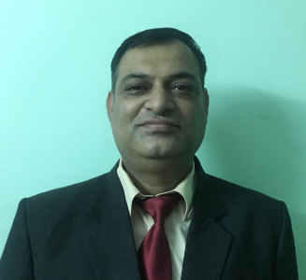
Senior Professional
Acknowledged for strengthening companies to lead in highly competitive situations, targeting assignments in Sales,Marketing and Services with an organization of high repute

- yogeet_chandna@rediffmail.com 9667063424
YOGEET CHANDNA

Profile Summary
- Achievement-driven professional
- Enterprising leader with excellent record of contributions that streamlined operations, invigorated businesses, heightened productivity & enhanced internal controls
- Combined multi-disciplinary experience (across Sales, Services, Strategy, Industry Analysis, Account & Portfolio Growth Ownership) to catapult the profits of the organization
- Leveraged entrepreneurial capability and skills in translating corporate vision, to overcome complex business challenges and deliver on high-impact decisions; renowned for driving an auction base to glide revenue
- Garnered buy-in from stakeholders behind major initiatives while at the same time building credibility and delivering on customer confidence
- Key member of the team that institutionalized strategic planning, control processes and systems businesses at a global level; gained various recognitions for not only the organizational growth performance but also excellence in its strategy formulation and other business processes
- Enhanced organizational reach and market share through the application of robust strategies, effective pricing and excellent client relationship management
- Directed cross-functional teams using interactive and motivational leadership; acknowledged for recruiting and mentoring leaders with an equal desire to win

Core Competencies
Sales & Business Development | Territory Growth Management | B2B Sales & Marketing
Strategic Market Positioning | Market & Competitive Analysis | Strategic Alliances
Distribution / Channel Management | Stakeholders Management | Product Launch and Exhibitions

Career Timeline
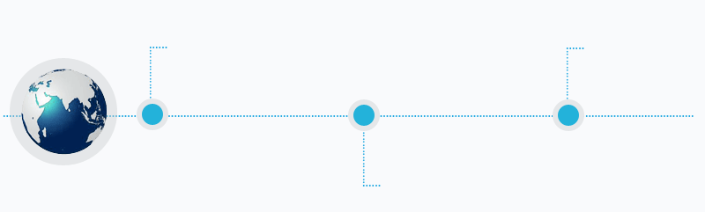
Jan’11 – Oct’12
Branch Head-Rajasthan, Hitachi Home and Life Solutions India Ltd.

Oct’12 – Nov’15
Sales Head, Hitachi Home and Life Solutions India Ltd.
Dec’15 – Till Date
Deputy General Manager, Johnson Controls Hitachi Air-conditioning India Ltd.
- Work Experience
General Manager, Benson Medical Equipments., Gurgaon Jan’20 –
Business Head
- Benson Medical Equipments (India) Pvt. Ltd. is a leading provider of durable medical equipment and specializes in Medical Gas Pipeline System, Modular OT’sRespiratory masks, Personnel protection Equipment and several other critical equipment and services with an experience of 23 years.
- They are also leading distributors of Mueller in India on exclusive basis, manufacturers of best quality Copper Tubes and Fittings & Refrigeration parts in USA. Selling copper parts & ref parts of Mueller to white goods companies
- Managing the team and operations for generating business revenue of the organization.
- Dealing with Hospitals, Health care centres, doctors and surgeons.
- Managing exports in SAARC countries for copper & doing imports from USA. Knowledge of Export/ Import Sales.
- Using Indiamart to generate leads and closures of leads for revenue growth.
- Creating & implementing innovative marketing strategies that will build brands, leading to increased awareness, relevance, revenue and aspiration among our target audience.
- Vision to seek out new promotional avenues to support, popularize and program objectives. Marketing Communication and Social Media Marketing for the company. - Help develop and execute growth targets and marketing strategies that align with the business plan and brand objectives.
- Assessing market requirements, developing recommendations for product direction, establishing market, pricing plans and strategies for GTM/RTM execution
- Working with agency and channel partner team to grow online by leveraging social media, SEO/SEM to increase awareness, preference to the brand-working with product marketing and sales to identify programs to generate incremental sales and/ or profitability.
- Preparing Business Plan for next one year and five years and shape Company strategy.
- Participation in various exhibitions at national and international levels.

Deputy General Manager, Johnson Controls., New Delhi Dec’15 –Oct’19
Key accounts & B2C Sales
- Setting target region wise and reviewing the same as per the market dynamics, leading the team in achieving the same
- Maintained & built relationships with all dealer, distributors and clients.
- Devising pricing strategy of products-sku and devising scheme for increasing volumes.
- Designing SOP regarding processes and communicating to the field.
- Acquiring new clients, expanding customer base and ensuring payment recoveries at scheduled time from Clients, Dealers & Distributors through branch managers & team.
- Clocking consistent growth in sales year on year for overall business development.
- Part of cross functional team for new product development
- Identifying & developing new streams for revenue growth (like AMC Retrofit, spares parts selling. Etc.) evaluate, negotiate, & manage business opportunities like new sales, projects which will contribute to the organizations short and long-term business goals
- Managing the project execution from the enquiry stage, to closing the order and execution the project of smart cities
- Conducting meetings and negotiations with customers to harvest business opportunities and protect the organizations business interests
- Executed an effective review and reporting system with respect to KRAs for the sales organization in alignment with business objectives of the organization
- Formulated strategy for channel management by gathering marketing information of the competitors and devising action plans.
- Developing relationship with Consultants/Architects/MEPs/Influencers for growth of business.
- Preparing Annual Operating Plan (AOP) for short and long term.
- Developing team members and ensure customer engagement with them for enhancing revenue.
- Assessment of area managers on their KPI on monthly/quarterly/yearly basis.
- Use of CRM app for customer service calls.

Sales Head(Telecom Sales)Hitachi Home and Life Solutions India Ltd. New Delhi Oct’12 – Nov’15
Key Result Areas:
- Headed Sales and Operations of Space Makers and FCU and provided critical equipment cooling solutions
- Formulated sales strategy by gathering marketing intelligence of the competitors and worked towards core areas that includes action plans to counter competition and focus on Corporate Social Responsibility
- Maintained excellent relations by ensuring business continuity through long-term partnerships with telecom companies.
- Did export of telecom products in Africa and SAARC countries.

Highlights:
- Administered key customers such as Telecom Operators that include Bharti Airtel, Vodafone, Idea Cellular, Aircel and BSNL
- Managed Telecom Infra: Indus Towers Ltd., GTL, Viom, Bharti Infratel, ATC Tower, ZTE, Huawei, Alcatel, Ericsson, TTML, Power Sector: Power Grid, ABB, Crompton Greaves, Alsthom, Siemens, GET Power, Railways: Railtel
- Introduced FCU business to Indus and ensured smooth operation of supply and installation of FCU of 28000
- Attained 74% growth in FY 12-13
- Successfully drove cross-functional teams for smooth operation of FCU project

Branch Head-Rajasthan, Hitachi Home and Life Solutions India Ltd., Jaipur Jan’11 – Oct’12
Highlights:
- Spearheaded 70 dealers, 6 distributors and 120 no sub dealers
- Defined& Forecast Sales Volume/Product Mix and achieved Profit Goal & Market Share
- Accelerated the turnover of the branch and improved share of business
- Gathered marketing intelligence of the competitors and devising strategies and action plans to counter competition

Previous Experience
Manager-Key Accounts Hitachi Home and Life Solutions India Ltd., New Delhi Jan’08 to Jan’11

Sales Manager-Solutions and Corporate Sales, Hitachi Home and Life Solutions India Ltd., Chandigarh Mar’01 – Jan’08

Area Sales Executive-Project Sales, Voltas Ltd. Delhi Sep’99 – Feb’01
(A Leading Engineering Company of Tata Group)

Engineer-Testing, Crompton Greaves, (Business Communication Division), Chandigarh Aug’94 – Aug’96

Education
- Master of Business Management in Marketing Management (First Class) with 67% from RA Podar Institute of Management, Jaipur in 1998
- Bachelor of Engineering in Electronics and Communication (First Class) with 75% from Panjab Engineering College, Chandigarh in 1994
- 12th from Mukand Lal National College, Yamunanagar with 85% in 1990
- 10th from St Thomas School, Jagadhri with 85% in 1988

Trainings Attended
- Key Account Management Training from IIM Calcutta
- ‘Internal Auditing-ISO’ conducted by Confederation of Indian Industry
- Management Development Programme’ conducted by Baroda Productivity Council

Personal Details

Languages Known: English, Hindi
Address: House No. 204, Icon towers,Omaxe Heights, Sector 86, Faridabad – 121002, Haryana

